Acknowledgement
I would like to express my sincere gratitude to Mr. M.I. Mohamed Nismy, my lecturer, for his invaluable guidance and support throughout this project. His expertise and insights were instrumental in helping me complete this task on web server technologies and hosting management services. I also extend my thanks to my peers and colleagues for their feedback and encouragement during the preparation of this report.
abstract
This report explores various web server technologies, server management services, and web hosting solutions that are integral to website hosting and management. It provides a comprehensive overview of popular web server technologies. Additionally, the report delves into server management tools. Furthermore, it examines different types of web hosting services, from shared hosting to cloud hosting and colocation,. The aim of this report is to highlight the importance of selecting appropriate technologies and services based on the specific requirements of a website.
Table of Contents
introduction 5
1.2.1 Different types of web server technologies 6
1.2.1.1 Apache Web Server 6
1.2.1.2 IIS Web Server 7
1.2.1.3 Nginx Web Server 8
1.2.1.4 LiteSpeed Web Server 8
1.2.2 Server Management Services 9
1.2.2.1 cPanel 9
1.2.2.2 Plesk 10
1.2.2.3 Webmin 10
1.2.2.4 Managed Cloud Services 11
1.2.3 Different Web Hosting services 11
1.2.3.1 Shared Hosting 11
1.2.3.2 Virtual Private Server (VPS) Hosting 11
1.2.3.3 Dedicated Hosting 12
1.2.3.4 Cloud Hosting 12
1.2.3.5 Managed Hosting 12
1.2.4 Comparison of Web Hosting Services 12
Conclusion 14
References 15

List of tables
Table 1: comparison of web hosting services 14

Table of figures
Figure 1: Apache server Icon (pngwing, 2024) 6
Figure 2: IIS web server (logowik, 2022) 7
Figure 3: Nginx server (safari, 2023) 8
Figure 4: litespeed (litespeed, 2024) web server 8
Figure 5: cPanel (Mazenauer, 2023) 9
Figure 6: plesk (wikipedia, 2023) 10
Figure 7: Webmin (webmin, 2020) 10
Figure 8: managed cloud services (weaver, 2024) 11

introduction
In today’s digital landscape, the ability to efficiently host and manage websites is crucial for businesses and individuals alike. Web server technologies and hosting services form the backbone of online platforms, ensuring they remain accessible, secure, and performant. A web server's primary function is to deliver web content to users upon request, making it a critical component of any website's infrastructure. Additionally, server management services provide the tools necessary to maintain the performance, security, and scalability of websites. This report explores various web server technologies, server management tools, and web hosting services, analyzing their roles in hosting and managing websites. By understanding these technologies and services, web administrators can make informed decisions that cater to the specific needs of their websites.

1.2.1 Different types of web server technologies
There are four main types of web servers

1.2.1.1 Apache Web Server

Figure 1: Apache server Icon (pngwing, 2024)
The Apache web server is widely used open-source software developed by the Apache Software Foundation. It supports a variety of operating systems, including Linux, Windows, Unix, FreeBSD, and Mac OS X. Approximately 60% of machines run on the Apache Web Server.
Its modular structure allows for easy customization. As open-source software, users can add their own modules to the server to tailor it to their specific needs.
Compared to other web servers, Apache is highly stable and administrative issues can be resolved with ease. It can be successfully installed on multiple platforms.
The latest versions of Apache offer improved performance, allowing for handling more requests than earlier versions. (Vinocha, 2024)

1.2.1.2 IIS Web Server
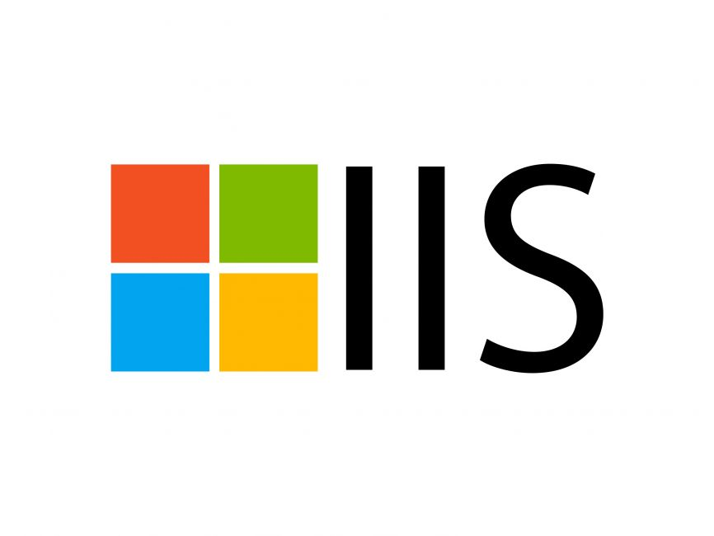
Figure 2: IIS web server (logowik, 2022)
IIS, a Microsoft product, is a server that provides similar features to Apache. However, unlike Apache, IIS is not open source, making it more difficult to customize or add personal modules.
IIS supports all platforms running the Windows operating system. It also offers good customer support, which can be beneficial for users encountering issues. (Linda Rosencrance, 2023)

1.2.1.3 Nginx Web Server

Figure 3: Nginx server (safari, 2023)
Nginx, another open-source web server, is known for its high performance, stability, simple configuration, and low resource usage. Unlike Apache, Nginx uses an event-driven architecture to handle requests efficiently, avoiding the overhead of threads. This approach results in predictable memory usage and high scalability. (M., 2024)
Nginx has gained popularity in recent years and is used by approximately 7.5% of domains worldwide. Many web hosting companies have adopted Nginx for its performance benefits.

1.2.1.4 LiteSpeed Web Server

Figure 4: litespeed (litespeed, 2024) web server
LiteSpeed is a commercial web server that offers high performance and serves as a drop-in replacement for Apache. Known for its improved performance and lower operating costs, LiteSpeed is compatible with many common Apache features, including .htaccess, mod_rewrite, and mod_security.
One of LiteSpeed's advantages is its ability to load Apache configuration files directly, making the transition from Apache seamless. It can replace Apache within 15 minutes without any downtime.
LiteSpeed simplifies the use and transition from Apache by replacing all Apache functions that traditional front-end proxy solutions cannot replicate. (Gireesh, 2022)

Apart from these technologies, there are many of them that exist. For example, Apache tomcat, Node.js, Lighttpd, OpenLight Speed, Jigsaw server and Sun Java system web server. (Godse, 2024)

1.2.2 Server Management Services

1.2.2.1 cPanel

Figure 5: cPanel (Mazenauer, 2023)
cPanel is a popular web hosting management tool, which offers a graphical interface for managing servers. It features domain management, file management, and backup solutions. (Mansoori, 2024)
cPanel pricing starts from 17.50 USD per month.

1.2.2.2 Plesk

Figure 6: plesk (wikipedia, 2023)
Plesk is similar to cPanel, but cross-platform (supports both Windows and Linux) (Ibeneme, 2023).
Plesk pricing starts from 14.13 USD per month.

1.2.2.3 Webmin

Figure 7: Webmin (webmin, 2020)
Webmin is free and open-source tool, allowing users to manage UNIX-based systems via a web interface (Cameron, 2023).

1.2.2.4 Managed Cloud Services
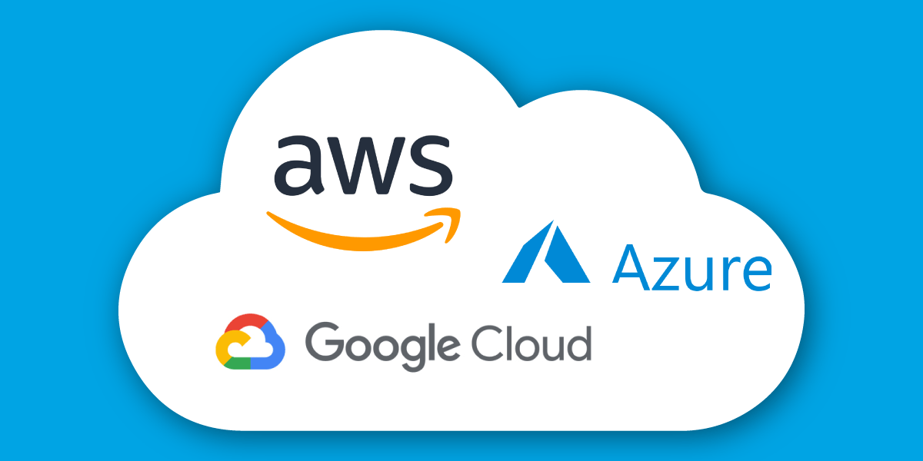
Figure 8: managed cloud services (weaver, 2024)
Cloud platforms like Amazon Web Services (AWS), Microsoft Azure, and Google Cloud offer managed hosting solutions, providing infrastructure as a service (IaaS) and platform as a service (PaaS) (Marketing, 2024).

1.2.3 Different Web Hosting services

1.2.3.1 Shared Hosting
Shared hosting is the most basic type of web hosting where multiple websites share the resources of a single server. This means that CPU, memory, and storage are divided among the hosted websites (S., 2024).

1.2.3.2 Virtual Private Server (VPS) Hosting
VPS hosting provides a virtualized server, which mimics a dedicated server but within a shared environment. It offers more resources than shared hosting but at a lower cost than dedicated hosting (Kuciel, 2023).

1.2.3.3 Dedicated Hosting
Dedicated hosting gives you an entire server dedicated solely to your website or application, providing maximum control and resources (Anderson, 2024).

1.2.3.4 Cloud Hosting
Cloud hosting uses a network of virtual and physical cloud servers to host websites, spreading resources and data across multiple servers. This ensures redundancy and maximizes uptime (Sonia Lelii, 2024).

1.2.3.5 Managed Hosting
In managed hosting, the hosting provider manages the server on behalf of the client, including maintenance, security, backups, and software updates (D., 2023).

1.2.4 Comparison of Web Hosting Services
Hosting Type | Cost | Control | Scalability | Performance | Security | Technical Expertise Required
Shared Hosting | Low | Limited (shared environment) | Low (fixed resources) | Low (shared with other websites) | Low (shared risks) | Minimal
VPS Hosting | Medium | High (virtual server, more control) | Moderate (can scale within limits) | Medium (dedicated resources) | Medium (better isolation) | Moderate
Dedicated Hosting | High | Full (complete control over server) | High (customize hardware and resources) | High (dedicated resources) | High (dedicated security measures) | High
Cloud Hosting | Varies (Pay-as-you-go) | Moderate to High (depends on service) | Very High (can scale easily) | High (distributed across servers) | High (redundancy and backups) | Moderate to High
Managed Hosting | High (includes management fees) | Low (limited to host's control panel) | Moderate (scales with plan) | Medium to High (depends on plan) | High (managed security) | Minimal
Table 1: comparison of web hosting services

Conclusion
In conclusion, the selection of appropriate web server technologies and hosting services is vital for the success and smooth functioning of any website. From widely used servers like Apache and Nginx to advanced server management tools such as cPanel and Plesk, the available options offer flexibility and control for website administrators. Additionally, the choice of hosting service whether shared, VPS, dedicated, or cloud should be based on factors like scalability, performance, and security. As websites continue to grow in complexity, understanding and implementing the right combination of technologies and services will ensure optimal performance and user satisfaction.

References
Anderson, T., 2024. bluehost. [Online]
Available at: https://www.bluehost.com/blog/what-is-dedicated-hosting/
[Accessed 13 11 2024].
Cameron, J., 2023. webmin. [Online]
Available at: https://webmin.com/docs/intro/#:~:text=Webmin%20is%20a%20program%20that,server%20and%20manage%20email%20forwarding.
[Accessed 12 11 2024].
D., D., 2023. mgt commerce. [Online]
Available at: https://www.mgt-commerce.com/blog/managed-hosting-services-advantages/
[Accessed 13 11 2024].
Gireesh, G., 2022. liquid web. [Online]
Available at: https://www.liquidweb.com/blog/what-is-litespeed-web-server/#:~:text=LiteSpeed%20Web%20Server%20(LSWS)%20is,%2C%20security%2C%20and%20load%20balancing.
[Accessed 10 11 2024].
Godse, P., 2024. milesweb. [Online]
Available at: https://www.milesweb.com/blog/hosting/web-server-types-web-servers/
[Accessed 24 9 2024].
Ibeneme, C., 2023. liquid web. [Online]
Available at: https://liquidweb.com/blog/what-is-plesk/
[Accessed 11 11 2024].
Kuciel, D., 2023. dreamhost. [Online]
Available at: https://dreamhost.com/blog/beginners-guide-vps/
[Accessed 13 11 2024].
Linda Rosencrance, S. J. B., 2023. tech target. [Online]
Available at: https://www.techtarget.com/searchwindowsserver/definition/IIS
[Accessed 9 11 2024].
M., A., 2024. hostinger tutorials. [Online]
Available at: https://www.hostinger.com/tutorials/what-is-nginx#:~:text=NGINX%20server%20operates%20on%20a,the%20actual%20processing%20of%20requests.
[Accessed 10 11 2024].
Mansoori, A. A., 2024. milesweb. [Online]
Available at: https://www.milesweb.com/ae/blog/control-panel/what-is-cpanel/#:~:text=cPanel%20is%20a%20control%20panel,streamlines%20your%20website%20management%20process.
[Accessed 10 11 2024].
Marketing, C. P., 2024. couchbase. [Online]
Available at: https://www.couchbase.com/blog/managed-cloud-services/
[Accessed 12 11 2024].
S., R., 2024. namecheap. [Online]
Available at: https://www.namecheap.com/guru-guides/what-is-shared-hosting/#:~:text=With%20Shared%20Hosting%2C%20a%20single,can%20host%20hundreds%20of%20users.
[Accessed 13 11 2024].
Sonia Lelii, E. S., 2024. tech target. [Online]
Available at: https://www.techtarget.com/searchstorage/definition/cloud-hosting
[Accessed 13 11 2024].
Vinocha, T., 2024. guvi. [Online]
Available at: https://www.guvi.in/blog/how-does-apache-work/#:~:text=Apache%20can%20be%20used%20as,of%20the%20server%2Dside%20code.
[Accessed 8 11 2024].

